**LAB # 6**



**CSE-203L Circuit & Systems-II Lab**

**Fall 2022**

**Submitted by: Ali Asghar**

**Registration No.: 21PWCSE2059**

**Class Section: C**

“On my honor, as student of University of Engineering and Technology, I have neither given nor received unauthorized assistance on this academic work.”

Student Signature: ______________

Submitted to:

**Engr. Faiz Ullah**

29th November, 2022

Department of Computer Systems Engineering

University of Engineering and Technology, Peshawar

**TITLE:**

**AC Superposition**

**OBJECTIVES:**

* To Analyze multi-source AC Circuits using AC Superposition Theorem.
* To study

**APPARATUS:**

* Oscilloscope
* AC Function Generator

**COMPONENTS:**

* 0.1 µF and 1 µF Capacitor
* 10 mH Inductor
* 1k Ω Resistor

**THEORY OVERVIEW:**

The Superposition Theorem can be used to analyze multi-source AC linear bilateral networks. Each source is considered in turn, with the remaining sources replaced by their internal impedance, and appropriate series-parallel analysis techniques employed. The resulting signals are then summed to produce the combined output signal. To see this process more clearly, the exercise will utilize two sources operating at different frequencies. Note that as each source has a different frequency, the inductor and capacitor appear as different reactance to the two sources.

**SUPERPOSITION PRINCIPLE:**

*The* ***principle of superposition*** *says that the* ***output of a linear circuit*** *due to* ***several inputs*** *working together is equal to the* ***sum*** *of the* ***outputs working separately****. The* ***inputs*** *to the* ***circuit*** *are the* ***voltages*** *of the* ***independent voltage******sources*** *and the* ***currents*** *of the* ***independent current sources.***

**CIRCUIT DIAGRAM:**

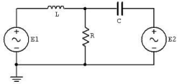

Figure 1

**PROCEDURE:**

To test the Superposition Theorem, sources E1 and E2 will be examined separately and then together.

**SOURCE ONE ONLY**

1. Consider the circuit of Figure 1 with C=0.1 µF, L=10mH, R=1kΩ, using only source E1=2 V p-p at 1 kHz and with source E2 replaced by a 0-V voltage source represented as a short circuit. Using standard series parallel techniques; calculate the voltages across R. Record the results in Table 1.
2. Build the circuit of Figure 1 using C=0.1 µF, L=10mH, and R=1kΩ. Replace E2 with 0-V voltage source represented as a short circuit. Set E1 to 2V p-p at 1 kHz, unloaded. Place probe one across E1 and probe two across R. Measure the voltages across R, and record in Table 1.

**Source Two Only**

1. Consider the circuit of Figure 1 using only source E2=2 V p-p at 10 kHz and with source E1 replaced by 0-V voltage source represented as a short circuit. Using standard series-parallel techniques; calculate the voltages across R. Record the results in Table 2.
2. Replace the short circuit with source E2 and set it to 2Vp-p at 10 kHz, unloaded. Replace E1 with 0-V voltage source represented as a short circuit. Place probe one across E2 and probe two across R. Measure the voltages across R and record in Table 2.

**Sources One and Two**

1. Consider the circuit of Figure 1 using both sources, E1=2Vp-p at 1 kHz and E2=2Vp-p at 10 kHz. Add the calculated voltages across R from Tables 1 and 2. Record the results in Table 3. 6. Replace the short circuit with source E1 and set it to 2Vp-p at 1 kHz, unloaded. Both sources should now be active. Place probe one across R. Measure the voltages across R, and record in Table 3.
2. Repeat the experiment for 1uF capacitor, 1mH inductor and 1kΩ resistor.

**OBSERVATIONS:**

1. **For V(p-p) = 2V, f1 = 1KHz, f2 = 10KHz, R = 1kΩ,L = 10mH, and C = 0.1µF**

**CIRCUIT DESIGN IN PROTEUS:**

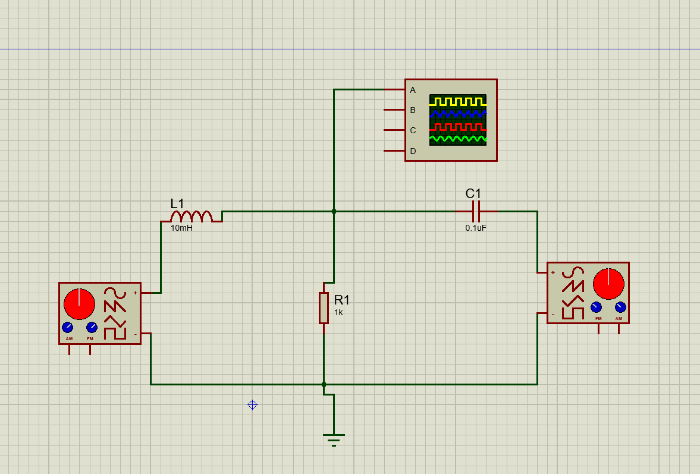

**SOURCE 1 ONLY:**

**Table 1**

|  |  |  |  |
| --- | --- | --- | --- |
|  | Theoretical | Experimental | %Deviation |
| VR | 1591.55 Ω | 1612.9 Ω | 1.32 % |

**SOURCE 2 ONLY:**

**Table 2**

|  |  |  |  |
| --- | --- | --- | --- |
|  | Theoretical | Experimental | %Deviation |
| VR | 1591.55 Ω | 1612.9 Ω | 1.32 % |

**SOURCEs 1 and 2:**

**Table 3**

|  |  |  |  |
| --- | --- | --- | --- |
|  | Theoretical | Experimental | %Deviation |
| VR | 1591.55 Ω | 1612.9 Ω | 1.32 % |

1. **For V(p-p) = 2V, f1 = 1KHz, f2 = 10KHz, R = 1kΩ,L = 10mH, and C = 1µF**

**CIRCUIT DESIGN IN PROTEUS**



**SOURCE 1 ONLY:**

**Table 1**

|  |  |  |  |
| --- | --- | --- | --- |
|  | Theoretical | Experimental | %Deviation |
| VR | 1591.55 Ω | 1612.9 Ω | 1.32 % |

**SOURCE 2 ONLY:**

**Table 2**

|  |  |  |  |
| --- | --- | --- | --- |
|  | Theoretical | Experimental | %Deviation |
| VR | 1591.55 Ω | 1612.9 Ω | 1.32 % |

**SOURCE 1 and 2:**

**Table 3**

|  |  |  |  |
| --- | --- | --- | --- |
|  | Theoretical | Experimental | %Deviation |
| VR | 1591.55 Ω | 1612.9 Ω | 1.32 % |

**CONCLUSION:**

We can conclude the following results from this experiment:

* Current is divided in three branches in RLC Parallel circuit while voltage remains constant.
* Kirchhoff’s Current Law (KCL) can also be extended for AC Circuits.
* We cannot measure current directly by oscilloscope. Alternatively, we use sense resistor to measure voltage drop across each element and then use Ohm’s Law for measuring current.